

INTRODUCTION TO PROBLEM SOLVING
USING PYTHON
SLOT:A11+A12+A13
FALL SEMESTER:2025-2026

NAME OF STUDENT: HARSHITA SINGH BAIS
REGISTRATION NUMBER: 25BAI11599
BRANCH: BTECH CSE (AIML)
TOPIC: DAILY NUTRITION AND HEALTH CALCULATOR

Daily Nutrition & Health Calculator - Project Report

Introduction
This project is a Python-based application that calculates personalized daily nutritional requirements based on user inputs such as age, gender, height, weight, and activity level. It provides values for BMI (Body Mass Index), ideal weight, protein, carbohydrates, fats, calories, water intake, vitamins, minerals, and sleep recommendations. The goal is to help individuals understand their body's nutritional needs in a simple and accessible way.

Problem Statement
Many people follow general diet plans without knowing whether they suit their body requirements. Nutritional needs vary for athletes, students, fitness beginners, and working individuals. The lack of simple tools for personalized nutrition calculation leads to unhealthy diet habits. Therefore, a system is required to calculate accurate nutrition recommendations based on body metrics.

Objective
- To calculate daily nutritional requirements using scientific formulas.
- To display results in a simple and easy-to-understand format.
- To assist people in making informed diet and health decisions.
- To provide personalized and accurate nutritional guidance.

Scope
This project is useful for students, athletes, fitness trainers, dieticians, and normal individuals. It helps understand personal nutrition needs rather than following generic diet charts. The program can be improved into a GUI application or mobile app.

Functional Requirements
- The system should allow users to input name, age, gender, height, weight, and activity level.
- It must calculate BMI, ideal weight, nutrition values, hydration and sleep requirements.
- It should display results step-by-step in clean output format.

Non-Functional Requirements
- Simple and user-friendly design.
- Fast and accurate calculations.
- Easy readability and clean output.
- Efficient execution without errors.

System Architecture
The project follows an Input-Process-Output structure:
- Input: User personal details.
- Process: Apply formulas to calculate BMI and nutritional values.
- Output: Display personalized daily nutrition chart.

Implementation Details
- The program is implemented using Python. It uses input() functions for user input, mathematical formulas for calculations, conditional statements for logic, and print statements for displaying results.

Daily Nutrient Requirement Table: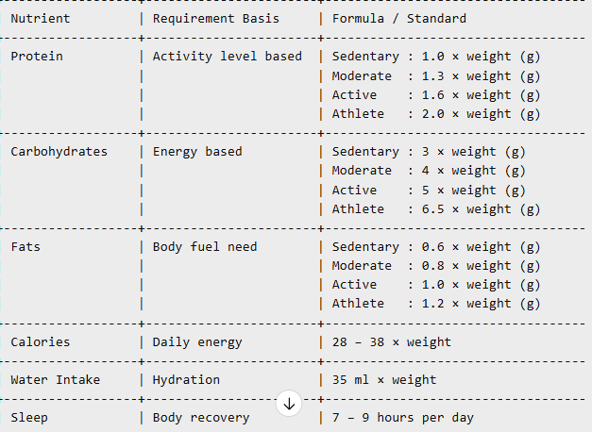
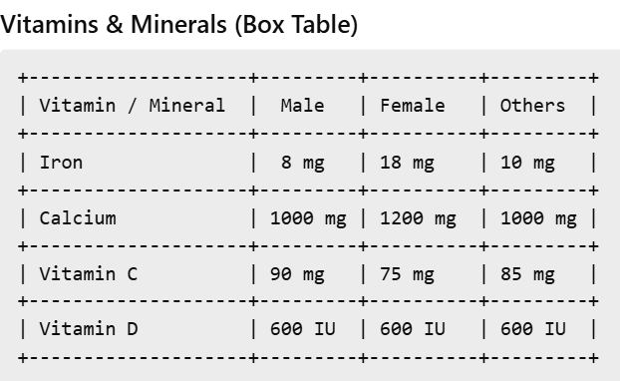

This project is useful for students, athletes, fitness trainers, dieticians, and normal individuals. It helps understand personal nutrition needs rather than following generic diet charts. The program can be improved into a GUI application or mobile app.

Flowchart
┌───────────────┐
│ START │
└──────┬────────┘
↓
┌──────────────────────┐
│ Enter User Details │
└─────────┬────────────┘
↓
┌──────────────────────┐
│ Perform Calculations │
└─────────┬────────────┘
↓
┌──────────────────────┐
│ Display Output │
└─────────┬────────────┘
↓
┌───────────────┐
│ END │

CODE
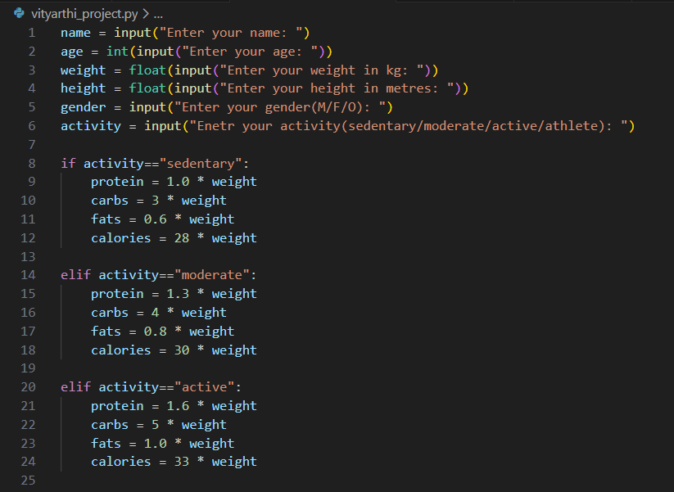

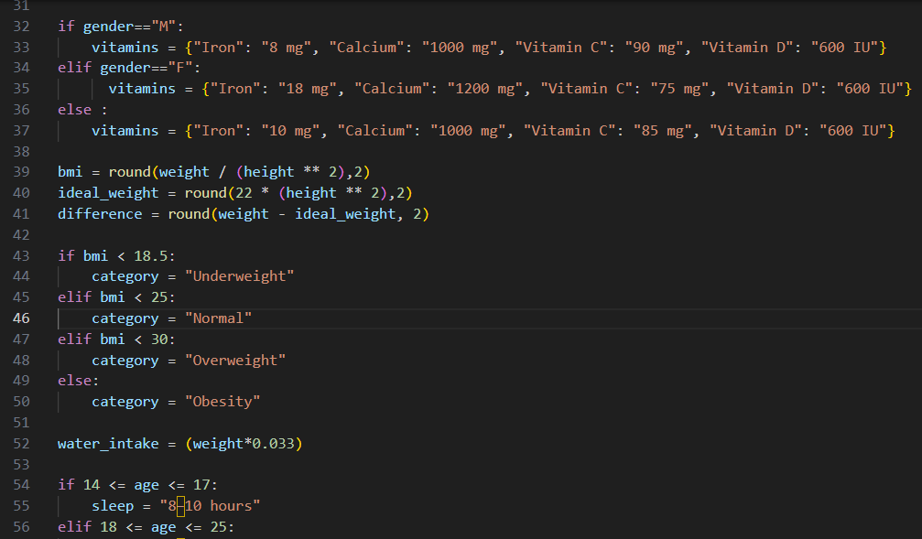
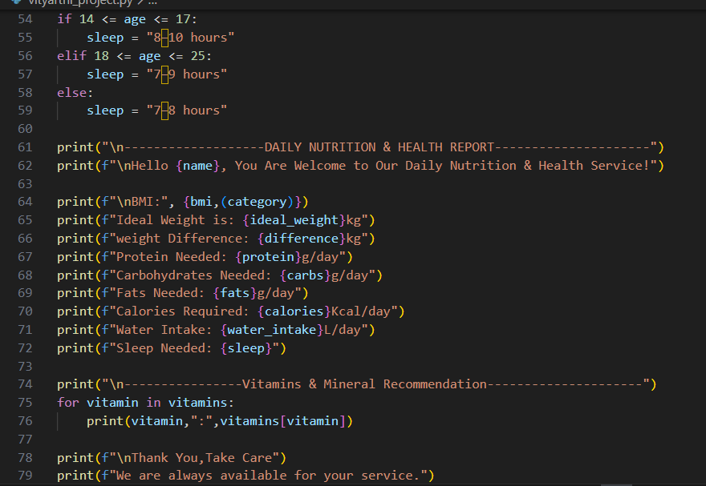

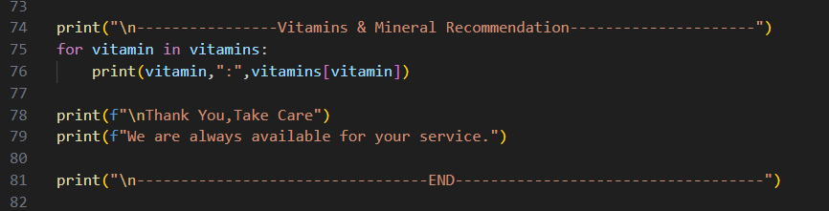

OUTPUT
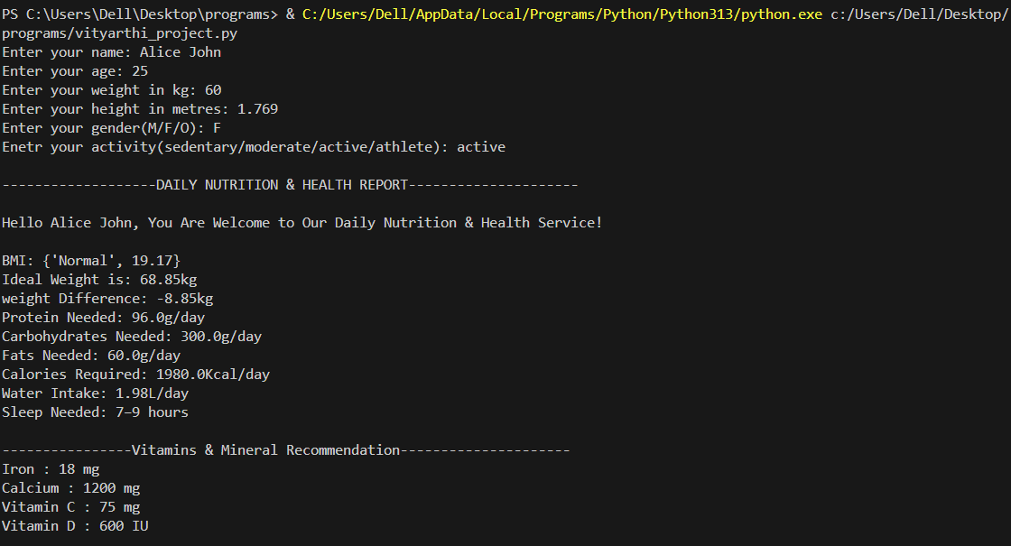

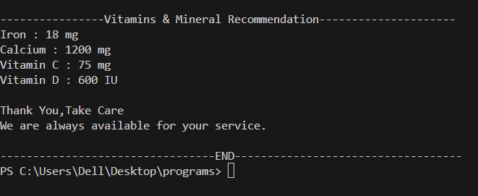

Testing Approach
Tested with multiple data sets including different age, gender, weight, and activity levels to ensure accuracy. Extreme values tested to check output reliability.

Challenges Faced
- Understanding correct nutrition formulas.
- Formatting clean output for readability.
- Debugging code execution in VS Code.

Learnings & Key Takeaways
- Learned BMI and nutrition science basics.
- Improved Python programming and debugging skills.
- Understood real-world health requirement calculations.

Future Enhancements
- Add GUI or mobile app.
- Export results as PDF.
- Add graphs and progress tracking.
- Integrate user login and database.

References
- WHO & Dietary Nutrition Guidelines
- BMI and Macronutrient calculation standards
- Python documentation

Thank You
We appreciate your time and consideration.

